1. Function Prototypes
2. What is #include
   1. Preprocessor directive
      1. Happens before compilation
      2. Processes all #
   2. Paste code of the given file into current file
   3. Used to include functions defined in other libraries
   4. #define
      1. Directive to the preprocessor
      2. Replace all instances of word
   5. Conditional directives
      1. Conditional statements in the prepocessor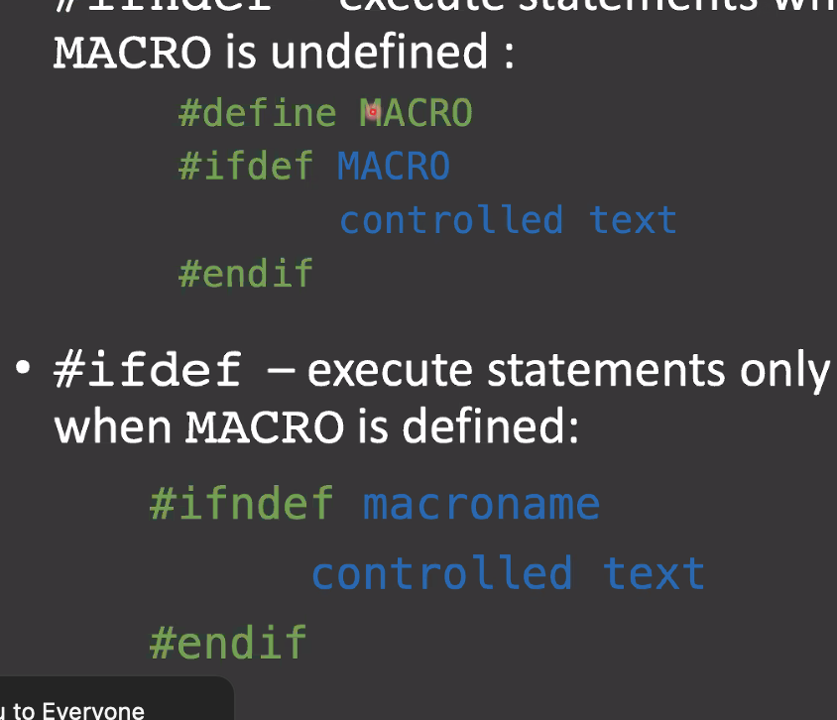
3. Header Files
   1. Only have things shared between source code files
      1. Function, Macro declarations
      2. Data structures
      3. Global Variables
      4. #include directive
   2. Uses extension .h
   3. Guard the headers with Conditional preprocessors
      1. 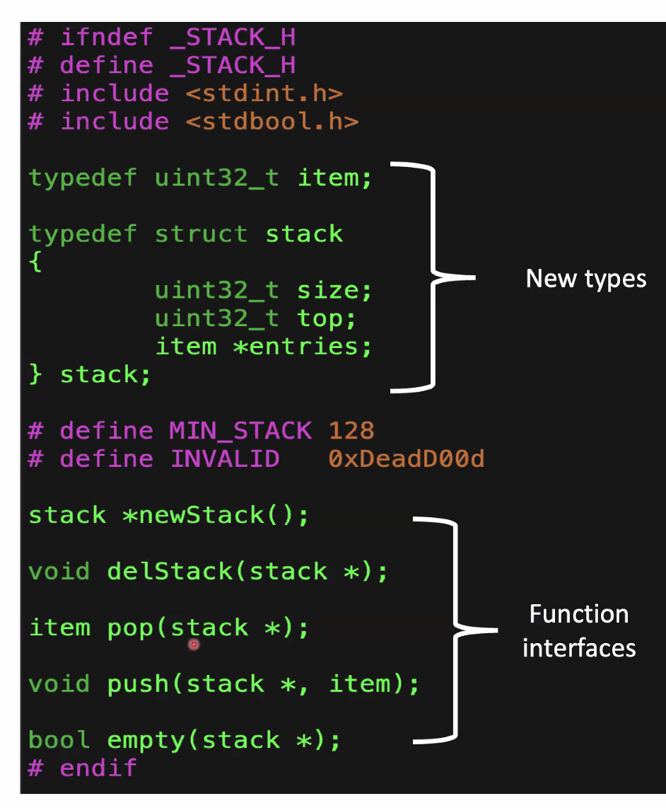
   4. Standard header files - stdio.h, inttypes.h, time.h, stdbool.h, ctype.h, math.h
4. Extern
   1. Allows C to access variables and functions
   2. 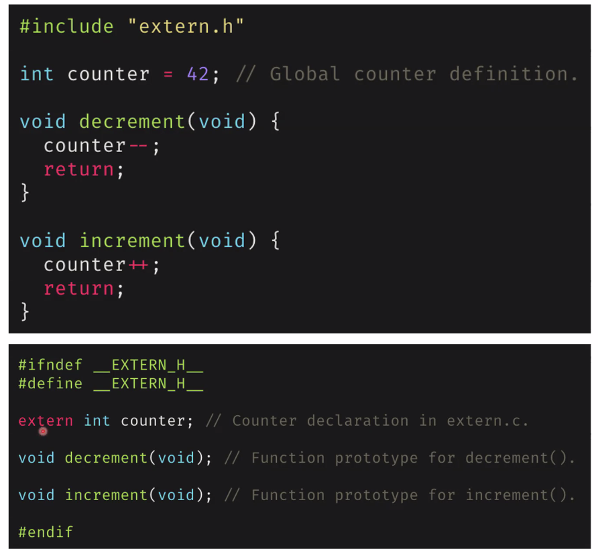
5. Static
   1. Declared inside and outside function
   2. Value of variable
6. Recursion
   1. Calls itself